2023 SHA Priorities
The coming year will be a key opportunity window for advancing progressive housing policy and advocacy efforts. Moreover, all SHA policies, priorities and actions should be viewed through a racial equity lens and promote and further racial equity.

- Funding for Sacramento: Advocate and work for adequate local affordable housing funding:
Strategies will include:
  - Help lead effort to develop a 2024 ballot initiative to generate revenue for affordable housing. Possible revenue sources could include sales tax, parcel tax, real estate transfer fee, etc.
  - Monitor and advocate for increases in local Affordable Housing Trust Funds in the County/City of Sacramento & other jurisdictions.
  - Continue working with State partners on effort to reduce voter threshold for affordable housing revenue measures.
  - Continued Advocacy & Monitoring of the Commercial Linkage Fees.
  - Identify other strategies to increase local funding resources for affordable housing, including affordable housing priorities for SACOG funding.
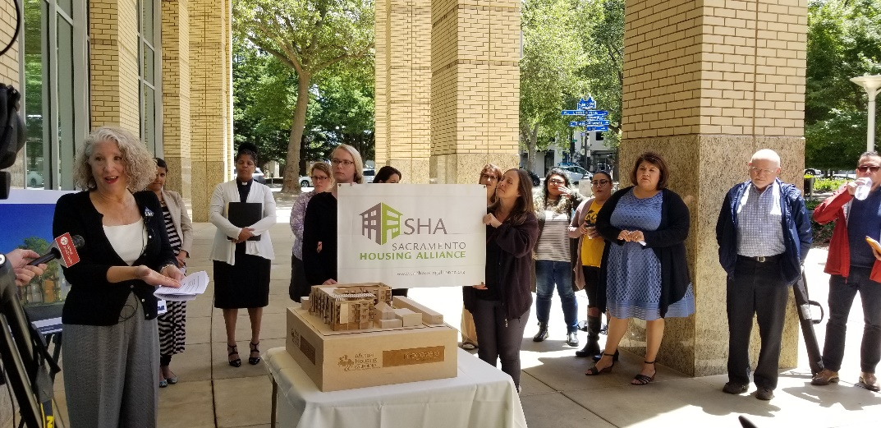
- Get People off the Streets and Keep People in their Homes—Advance affordable housing production and preservation as the most important strategies to end homelessness. Support our allies in their work to end homelessness. Support programs and policies to keep people in their homes:
Strategies will include:
    - Displacement Mitigation—including working as a member of
Sacramento Investment Without Displacement Coalition (SWID), SHA will continue to lead the Housing Team and develop affordable housing strategies (including funding) and displacement prevention and mitigation strategies (e.g. tenant assistance, rehabilitation supports and mortgage assistance).
    - CalAim/Medi-Cal Service advocacy for PSH (Permanent Supportive Housing.
    - Develop Mobile Home Park Preservation strategies and advocacy.
    - Monitor and advocate for effective implementation of Sacramento Tenant protection program — strengthen eviction protections.
    - Collaboration with partner organizations on local initiatives to create and preserve affordable housing.
- Racial Equity Action Plan: SHA will develop an overarching Racial Equity Statement and Goals to guide all our work.
Strategies will include:
  - Develop SHA racial equity statement and goals.
  - Produce Menu of Programs SHA can advocate for to Affirmatively Further Fair Housing.
  - Creating a Local Clearinghouse of Developers, Contractors, and Subcontractors of Color.
  - Improve access to credit and lending/ Community Reinvestment Act Activities
- Local Policies and Programs to Produce and Preserve Affordable Homes— Develop and advocate for effective actions to develop significantly more subsidized and regulated affordable housing and preserve affordability of existing housing. Develop strategies to combat opposition to housing.
Strategies include:
  - Win campaign to get the City of Sacramento to adopt an effective CBA Ordinance campaign.
  - Housing Element Implementation, Tracking, and Enforcement.
  - Influence the review and update on Mixed Income Housing/ inclusionary ordinances to strengthen.
  - Work with community and housing organizations to advance potential TOPA/COPA ordinance. Possibly in context of TCE convened cohort-building on Acquisition/Preservation strategies for smaller scale housing properties.
  - As time allows, influence the City’s Missing Middle Housing Study/We Build Sacramento initiative (to allow duplexes, triplexes and fourplexes in single family zones).
  - Influence Electrification Ordinances - Continue work with SMUD on effective virtual net metering standards.
  - Engage with CADA as its scope of activities intersects with City of Sacramento’s policies and programs for the overall downtown area, as well as State initiatives to transform State buildings to residents.
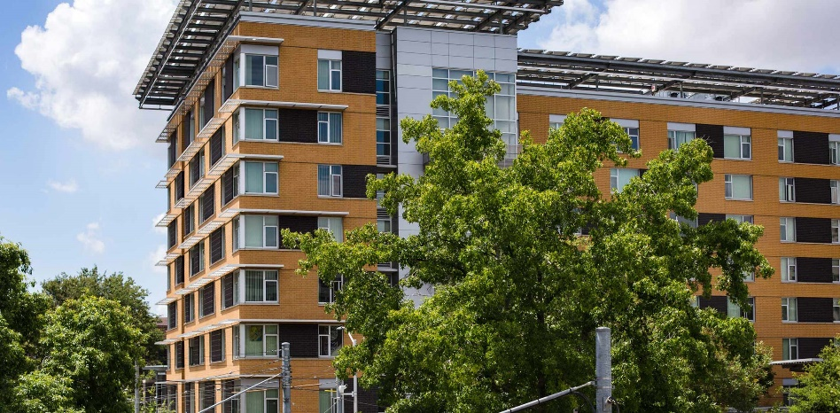
- State Advocacy — Working with Statewide partners to advocate for affordable housing funding in State Budget and Legislative initiatives, legislative advocacy for priority bills, and advocate to State Affordable Housing Agencies to ensure State housing funding standards and regulations allow the Sacramento region to effectively compete.
Strategies Include:
  - Continued advocacy regarding State budget including push for refunding of MHP.
  - Support early campaign planning and strategy for statewide affordable housing measures in 2024.
  - Engage with the Stable Homes Coalition efforts on a $500mil Budget Ask to provide funding to purchase market rate Natural Occurring Affordable Housing (NOAH) and create deed restricted affordable housing by mission driven affordable developers.

  - Influence HCD’s design of program guidelines and regulations for all programs. Review and engage in adoption and revision of all programs utilized by affordable housing developers in our region.
  - Early in 2023, prioritize State bills for advocacy that either support SHA policy priorities or would be detrimental to our priorities.
  - Advocate that new State policy to transform State buildings in Sacramento into housing includes a significant percentage of units as affordable.

